Customer Shopping Behavior Analysis Project Report

2. Problem Statement
In today's competitive retail market, understanding customer shopping behavior is essential for improving business performance and customer satisfaction. Retail businesses generate large amounts of transactional data, but deriving meaningful insights from this data is challenging without proper analysis. This project analyzes customer purchasing patterns, spending behavior, subscription status, payment preferences, product categories, and customer demographics using Python, SQL, and Power BI. The objective is to transform raw data into actionable insights that support better business decisions.
Dataset, notebook, SQL script and Power BI file were provided.

1. Data Collection
Dataset rows: 3900, columns: 18

2. Data Understanding
Customer ID, Age, Gender, Item Purchased, Category, Purchase Amount (USD), Location, Size, Color, Season, Review Rating, Subscription Status, Shipping Type, Discount Applied, Promo Code Used, Previous Purchases, Payment Method, Frequency of Purchases

3. Data Cleaning (from notebook)
df.isnull().sum()/len(df) * 100
df["Review Rating"] = df.groupby("Category")["Review Rating"].transform(lambda x: x.fillna(x.median()))
df.isnull().sum()
df.columns = df.columns.str.lower()
df.columns = df.columns.str.replace(" ",'_')
df = df.rename(columns = {'purchase_amount_(usd)':'purchase_amount'})

4. SQL Analysis
CREATE DATABASE CUSTOMER_BEHAVIOUR;
USE CUSTOMER_BEHAVIOUR;
CREATE TABLE customer_behaviour (
customer_id INT PRIMARY KEY,
age INT,
gender VARCHAR(20),
item_purchased VARCHAR(100),
category VARCHAR(100),
purchase_amount DECIMAL(10,2),
location VARCHAR(100),
size VARCHAR(20),
color VARCHAR(50),
season VARCHAR(20),
review_rating DECIMAL(3,2),
subscription_status VARCHAR(20),
shipping_type VARCHAR(50),
discount_applied VARCHAR(10),
previous_purchases INT,
payment_method VARCHAR(50),
frequency_of_purchases VARCHAR(50),
age_group VARCHAR(30),
purchase_frequency_days INT
);
-- CHECK THE NUMBER OF RECORDS
select count(*) from customer_behaviour;
-- Q1. What is the total revenue generated by male vs. female customers?
SELECT GENDER, SUM(PURCHASE_AMOUNT) AS REVENUE
FROM CUSTOMER_SHOPPING_BEHAVIOR
GROUP BY GENDER;
-- Q2. Which customers used a discount but still spent more than the average purchase amount?
SELECT CUSTOMER_ID, PURCHASE_AMOUNT
FROM CUSTOMER_SHOPPING_BEHAVIOR
WHERE DISCOUNT_APPLIED = "yes"
AND PURCHASE_AMOUNT >= (SELECT AVG(PURCHASE_AMOUNT)FROM CUSTOMER_SHOPPING_BEHAVIOR);
-- Q3. Which are the top 5 products with the highest average review rating?
SELECT ITEM_PURCHASED, AVG(REVIEW_RATING) AS AVERAGE_PRODUCT_RATING
FROM CUSTOMER_SHOPPING_BEHAVIOR
GROUP BY ITEM_PURCHASED
ORDER BY AVG(REVIEW_RATING) DESC
LIMIT 5;
-- Q4. Compare the average Purchase Amounts between Standard and Express Shipping.
SELECT SHIPPING_TYPE,AVG(PURCHASE_AMOUNT) FROM CUSTOMER_SHOPPING_BEHAVIOR
WHERE SHIPPING_TYPE IN ("STANDARD","EXPRESS")
GROUP BY SHIPPING_TYPE ;
-- Q5. Do subscribed customers spend more? Compare average spend and total revenue between subscribers and non-subscribers.
SELECT SUBSCRIPTION_STATUS,COUNT(CUSTOMER_ID) AS TOTAL_CUSTOMERS,
AVG(PURCHASE_AMOUNT) AS AVG_SPEND,
SUM(PURCHASE_AMOUNT) AS TOTAL_REVENUE
FROM CUSTOMER_SHOPPING_BEHAVIOR
GROUP BY SUBSCRIPTION_STATUS
ORDER BY TOTAL_REVENUE DESC, AVG_SPEND DESC;
-- Q6. Which 5 products have the highest percentage of purchases with discounts applied?
SELECT ITEM_PURCHASED,
ROUND(SUM(CASE WHEN DISCOUNT_APPLIED = 'YES' THEN 1 ELSE 0 END) / COUNT(*) * 100,2) AS DISCOUNT_RATE
FROM CUSTOMER_SHOPPING_BEHAVIOR
GROUP BY ITEM_PURCHASED
ORDER BY DISCOUNT_RATE DESC
LIMIT 5;
-- Q7. Segment customers into New, Returning, and Loyal based on their total number of previous purchases, and show the count of each segment.
WITH CUSTOMER_TYPE AS (
SELECT CUSTOMER_ID,PREVIOUS_PURCHASES,
CASE WHEN PREVIOUS_PURCHASES = 1 THEN "NEW"
WHEN PREVIOUS_PURCHASES BETWEEN 2 AND 10 THEN "RETURNING"
ELSE "LOYAL"
END AS CUSTOMER_SEGMENTS
FROM CUSTOMER_SHOPPING_BEHAVIOR)
SELECT CUSTOMER_SEGMENTS,COUNT(*) AS "NUMBER OF CUSTOMERS"
FROM CUSTOMER_TYPE
GROUP BY CUSTOMER_SEGMENTS;
-- Q8. What are the top 3 most purchased products within each category?
WITH ITEM_COUNTS AS (
SELECT CATEGORY,ITEM_PURCHASED,
COUNT(CUSTOMER_ID) AS TOTAL_ORDERS,
ROW_NUMBER() OVER(PARTITION BY CATEGORY ORDER BY COUNT(CUSTOMER_ID) DESC)AS ITEM_RANK
FROM CUSTOMER_SHOPPING_BEHAVIOR
GROUP BY CATEGORY,ITEM_PURCHASED)
SELECT ITEM_RANK,CATEGORY,ITEM_PURCHASED,TOTAL_ORDERS
FROM ITEM_COUNTS
WHERE ITEM_RANK <=3;
-- Q9. Are customers who are repeat buyers (more than 5 previous purchases) also likely to subscribe?
SELECT SUBSCRIPTION_STATUS,
COUNT(CUSTOMER_ID) AS REPEAT_BUYERS
FROM CUSTOMER_SHOPPING_BEHAVIOR
WHERE PREVIOUS_PURCHASES > 5
GROUP BY SUBSCRIPTION_STATUS;
-- Q10. What is the revenue contribution of each age group?
SELECT AGE_GROUP,SUM(PURCHASE_AMOUNT) AS TOTAL_REVENUE
FROM CUSTOMER_SHOPPING_BEHAVIOR
GROUP BY AGE_GROUP
ORDER BY TOTAL_REVENUE DESC;

5. Power BI Dashboard
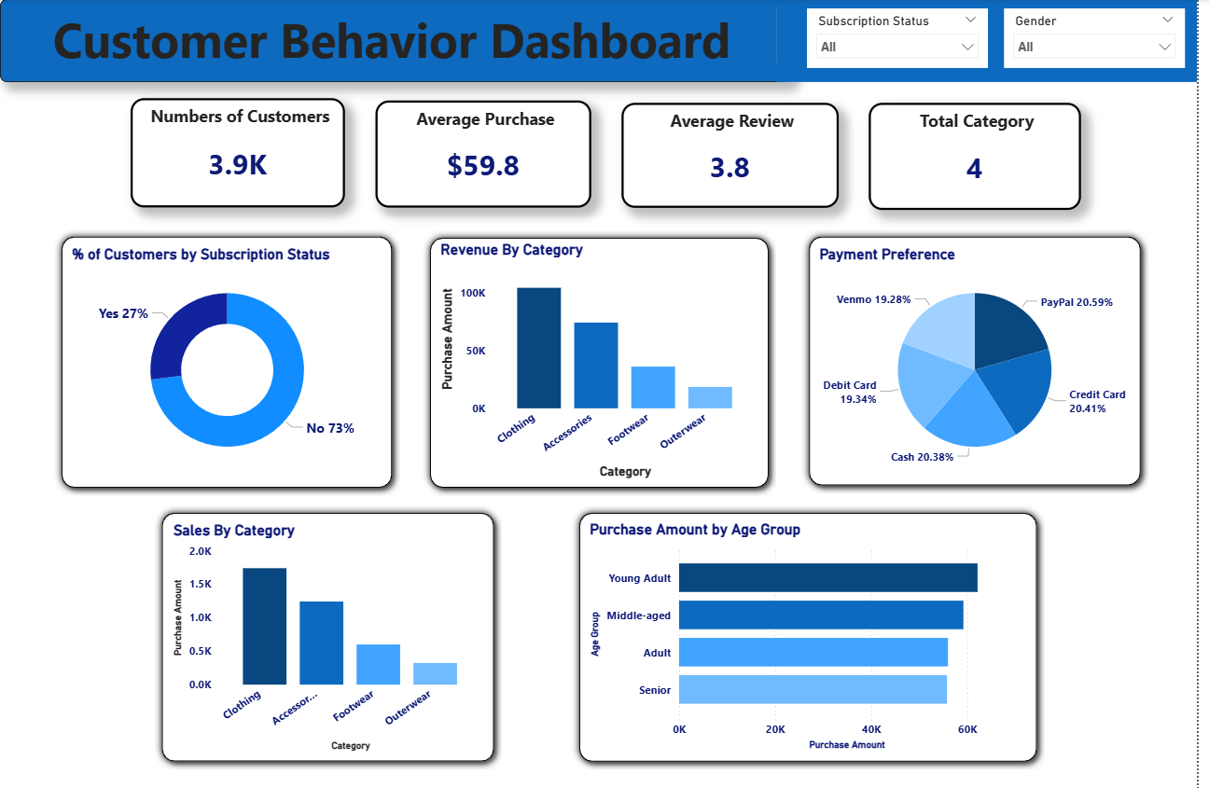
Dashboard built in Power BI with KPIs, bar charts, slicers and interactive visuals.

6. Business Insights
- Analyze customer spending
- Preferred payment methods
- Category performance
- Subscription behavior
- Discount impact
- Seasonal trends

